Laboratory work 4
Binary tree visualization

Task
Create a binary tree according to the student number and perform its visualization with D. Knuth's algorithm.
6. Integers in the range [-250, 300];

The binary tree was implemented in Python using a Node class to represent each tree element, storing the key, left and right children, and a reference to the parent node. The Tree class managed insertion of nodes via the add_node method. The method recursively traverses the tree to insert a new node at the correct position according to BST properties. The chosen integer dataset included positive, negative, and zero values to illustrate a balanced tree structure: [10, 13, 14, 8, 9, 7, 11, -50, 0, 25, 100, 200].
The visualization was created using matplotlib. Nodes were displayed as sky-blue circles, with the key values labeled at the center. Edges connecting parent and child nodes were drawn as straight black lines. The figure size was set to 12×8, and axes were turned off. The recursive draw_edges function ensured that all connections in the tree were drawn correctly. This combination of node positioning and edge drawing provides a clear representation of the BST structure.
The final binary tree diagram clearly shows the hierarchical organization of the dataset. Negative numbers are correctly placed in the left subtree, positive numbers in the right subtree, and the root node is central. The Knuth-style layout makes the structure readable and visually balanced, highlighting relationships between parent and child nodes. This visualization method is effective for presenting tree-based data structures in academic reports or teaching materials.

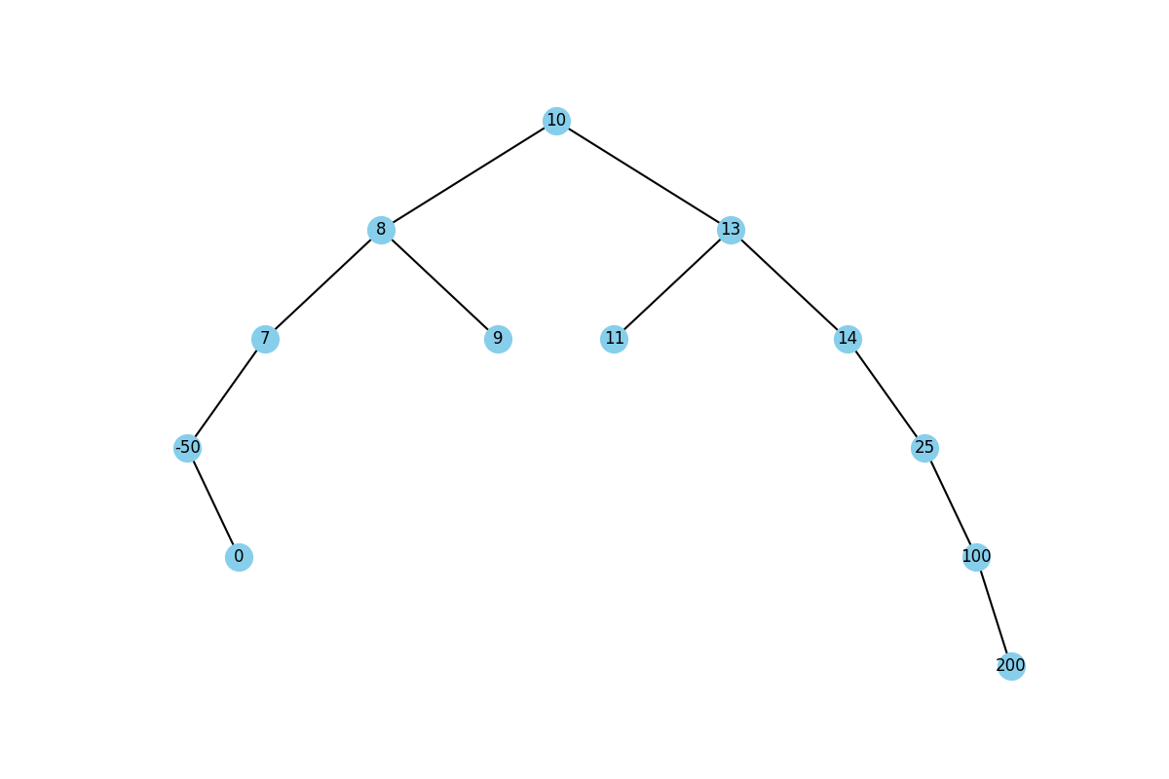
Figure 1 - Binary tree

